International Workshop

Large Irrigation Works and Urban Growth in the Archaeological Record of
Central Asia

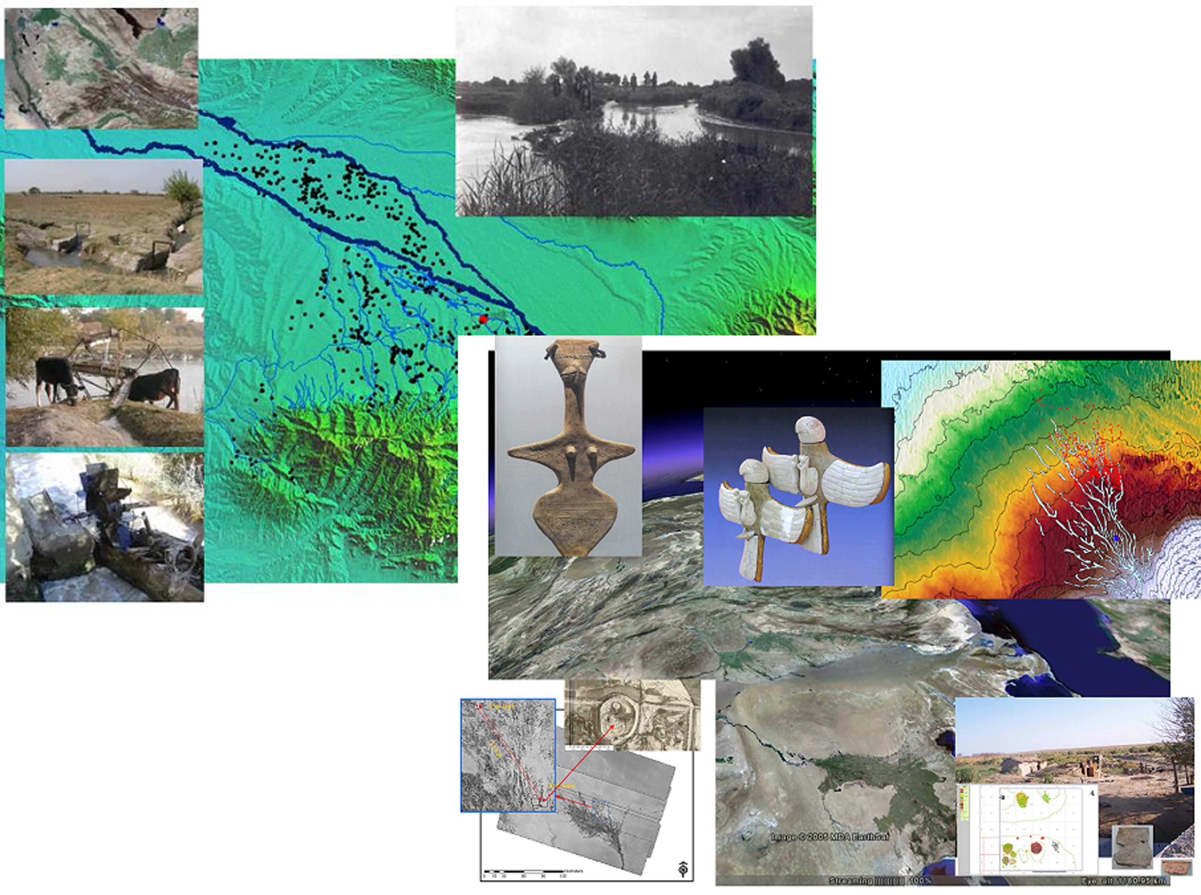

University of Bologna
Department of Archaeology
March, 23rd–24th 2007

Sala Conferenze
Residenza Galletti Abbiosi
Via di Roma, 140 Ravenna

Info
Barbara Cerasetti +39.328.3416692 ; cerasett@alma.unibo.it
Simone Mantellini +39.339.4144354 ; simonemantellini@gmail.com

