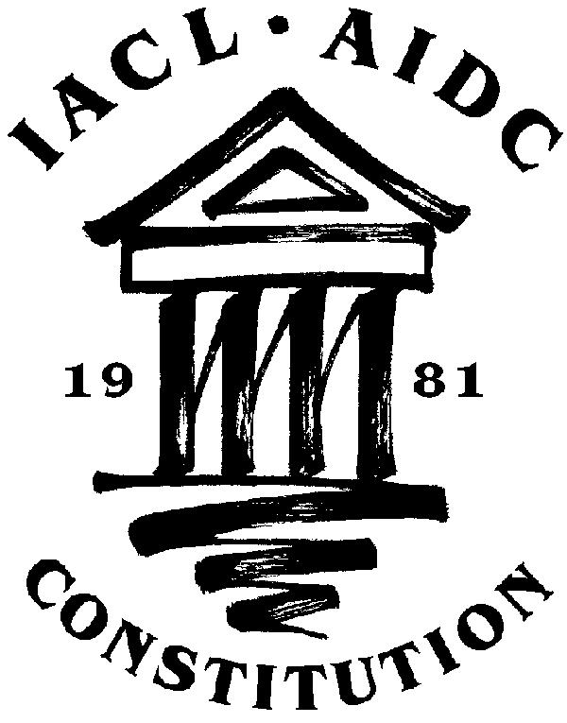


IACL ROUND TABLE
22-24 March 2007, Ravenna, Italy

Theme: "Constitution and Culture(s)"

Venue: The Faculty of Law of the Ravenna campus of the University of Bologna

Programme

Thursday 22 March 2007, Arrivals in Bologna
14.00 Meetings of IACL Commissions
(venue: Fondazione Carisbo, Via Farini n. 15, Bologna )

19.00 Dinner

21.00 Bus transfer to Ravenna

Friday 23 March 2007, 9.30 Opening of the Round Table

Prof. Stefano Canestrari (Dean of the Law Faculty of the University of Bologna)
Prof Cheryl Saunders (Melbourne, Australia), President of the IACL
-Prof. Giuseppe de Vergottini (University of Bologna, Italy, EC of the Italian Association of Constitutional Law)

10.30 Panel I: Constitutional Accomodation of Cultural and Religious Pluralism

Chair: Prof.

Prof. Didier Maus (University of Paris I, France) “Constitution and religious pluralism in France”
Prof. Kevin Boyle (University of Essex, UK) "Old problems and new problems: constitutional accommodation of religious pluralism in the UK and Ireland"
Prof. Ruth Rubio-Marin (University of Seville, Spain) “Constitutional Dimensions in the Accomodation of Linguistic Diversity”
Prof. Martin Scheinin (Åbo Akademi University, Finland) “Popular sovereignty and the coexistence of distinct "peoples" within one state”'

13.00 Lunch.
14.30 Panel II: Constitutional Cultures and the European Constitution- Making Process

Chair: Prof. Ginevra Cerrina Feroni (university of Florence, Italy)

- Prof. Peter Häberle (University of Bayreuth, Germany) “Education and Culture as Elements of the European Citizenship”
-Prof. Paolo Ridola (University of La Sapienza, Rome, Italy) “Constitutionalism and the European Constitutional Identity”
-Prof. Lucia Serena Rossi (University of Bologna, Italy): “Constitutional Cultures and the European Court of Justice”
: -Prof. Bruno de Witte (European University Institute and University of Maastrich, the Netherlands) "European law as a challenge to national constitutional identities"

20.30 Dinner

Saturday 24 March 2007

9.30 Panel III: Cultural Values in Constitutional Adjudication

Chair: Prof. Cheryl Saunders (Melbourne, Australia)

- Prof. Reva Siegel and Prof. Robert Post (Yale Law School, USA) "Constitutional Patriotism and Constitutional Culture"
- Justice Lech Garlicky (ECHR, Strasbourg): “Cultural Values in Supranational Adjudication: Is there a "cultural margin of appreciation" in Strasbourg ?”
-Justice Guido Calabresi (Court of Appeals for the Second Circuit, USA)” “Melting Pot or MultiCulturalism: Reactions to Two Forms of Equality”
- Prof. Luc Trembley (University of Montreal, Canada) «Multiculturalism in Canadian Constitutional Adjudication: the Regime of Citadels»

Concluding Remarks:

Prof. Susanna Mancini (University of Bologna, Italy)
Prof. Michel Rosenfeld (Cardozo Law School, USA)

14,30 Meetings of IACL Commissions
(Venue: The Faculty of Law of the Ravenna campus of the University of Bologna)

20,30 Dinner

