UNIVERSITÀ DEGLI STUDI DI BERGAMO
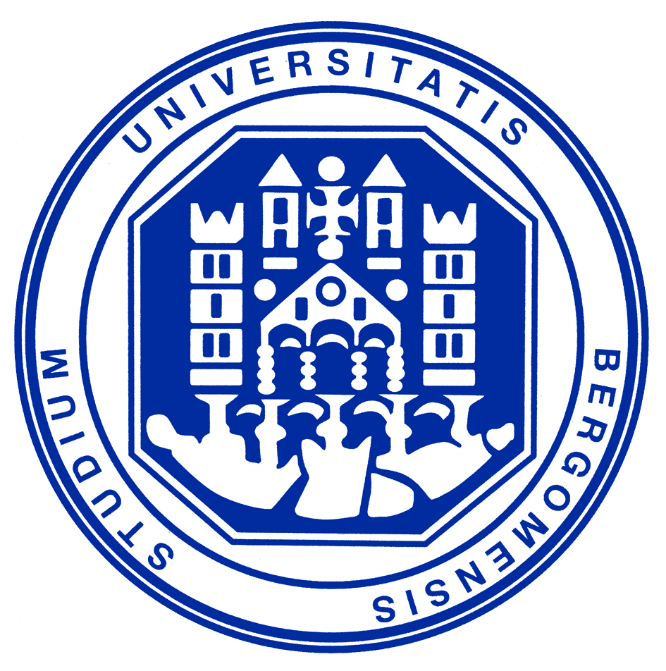

Dipartimento di Scienze della Persona
Scuola di Dottorato in Antropologia ed Epistemologia della Complessità
CE.R.CO.

International Seminar
Transnational Migrations and Dis-Located Borders
June 20, 2008

In recent years, a growing number of researchers are working on migration with a transnational perspective as well as on borders. The aim of this international seminar is to bring some of them together and encourage comparative discussion on these themes.
More precisely, the seminar would like to overcome the commonsense dichotomy between transnational migration and borders. Apparently, borders are often regarded as the very basis for establishing a modern, territorial and “mono-topic” logic legitimating an essentialised view of the world as a mosaic of Nation-States. Transnationalism seems to challenge, in turn, this long-standing logic by introducing a new inclination to think in terms of flows, mobility, and networks. Migration scholars increasingly emphasise how migrants have become transmigrants, living in-between sending and receiving societies and maintaining strong ties to both throughout the migration process. Migration is thus shaping transnational spaces encompassing several countries in a process that challenges territorial separations and national borders. Sure, the world has always been transnational and most of current mobile processes have been anticipated for a long time along and across borders. On the other hand, speed, intensity and frequency are new characters of contemporary transnationalism.
Acknowledging the limitations of our conceptual and analytical tools urges us to move away from what is called “methodological nationalism”, which assumes that the nation/state/society is the natural socio-political form of contemporary world. However, what is worth pointing out is that migration challenges borders, but is still regulated by borders. It may erase some borders, but it does not in itself prevent the creation of other borders that recreate divisions along other lines. Accordingly, borders have not been disappearing but they are moving themselves everywhere. This dis-placement of borders can be conceived as a paradoxical movement from the “edge” to the “centre” of public space. Borders are considered as in-between spaces, a sort of interface where new “mestizo” and “cosmopolitan” cultures and practices may take shape. Furthermore, borders are no longer the mere “line” separating a nation-state from another. They can be dis-located spaces, which express the multiple localities and spatialities of state and society. Furthermore, what is worth exploring is how such b-ordering processes are in the very heart of European identity and citizenship that are defined in the complex interplay between moving, dis-located external borders and the multiplication of internal ones. Both external and internal borders point to a set of issues at the stake of present political and academic debates: the former are related to (im)migration policies, diasporas as well as transnationalism; the latter focus instead on different forms of ethnicisation, old and new racisms, citizenship, as well as the idea of nation and the processes of social differentiation it implies.
The seminar wants to be a cross-disciplinary conversation between scholars that seek to critically reconsider these issues and their translation in the conceptions of identity, sovereignty and citizenship as complex, mobile and relational processes. Neither should be regarded mobility and flows as opposed to the existence of places; nor are borders the antithesis of diasporas and transnational migration. The dialectics between contemporary modes to organize the migration experience on the one hand, and, on the other hand, the transformation of borders can be regarded, on the contrary, as an entry point to investigate contemporary mobile networks highlighting, at the same time, the variety of their meanings and practices.

Bruno Riccio
(University of Bologna/Ph.D. Programme in Anthropology and Epistemology of Complexity, University of Bergamo)

Chiara Brambilla
(University of Bergamo, Ph.D. Programme in Anthropology and Epistemology of Complexity)

SCIENTIFIC COMMITTEE:
Prof. Mauro Ceruti
Prof. Matilde Callari Galli
Prof. Gianluca Bocchi
Dr. Bruno Riccio
Dr. Chiara Brambilla

PROGRAMME:

JUNE 20, 2008

9:30 a.m. – Welcome and Opening Address: Mauro Ceruti (Coordinator of the Ph.D. Programme in Anthropology and Epistemology of Complexity, University of Bergamo)

SESSION I: Transnational Perspectives on Migration and “Methodological Nationalism”
Chair: Cristina Grasseni (University of Bergamo, Ph.D. Programme in Anthropology and Epistemology of Complexity)

9:45 a.m. – Introduction – Matilde Callari Galli (University of Bologna - Ph.D. Programme in Anthropology and Epistemology of Complexity, University of Bergamo)

10:00 a.m. – Nina Glick Schiller (University of New Hampshire - University of Manchester)
Where Do We Go From Here? Theorizing Transnational Migration and Locality in a Neo-liberalizing World

10:45 a.m. – Coffee Break

11:15 a.m. – Pnina Werbner (University of Keele)
The Phony Red Herring of the Critique of Methodological Nationalism and the Anthropological Project

12:00 a.m. – Discussion – Discussant: Bruno Riccio (University of Bologna - Ph.D. Programme in Anthropology and Epistemology of Complexity, University of Bergamo)

12:45 a.m. – Lunch

SESSION II: Dis-located Borders and Networks, or Networked Borders
Chair: Stefano Tomelleri (University of Bergamo, Ph.D. Programme in Anthropology and Epistemology of Complexity)

2:15 p.m. – Introduction: Chiara Brambilla (University of Bergamo, Ph.D. Programme in Anthropology and Epistemology of Complexity)

2:30 p.m. – Didier Fassin (IRIS, Interdisciplinary Research Institute in Social Sciences; EHESS-Université Paris Nord)
Borders and Boundaries. Articulating Immigration Policies and Racialization Processes

3:15 p.m. – Henk van Houtum (Radboud University Nijmegen – NCBR)
The Janusface of B/Ordering and Othering

4:00 p.m. – Coffee Break

4:30 p.m. – Olivier Thomas Kramsch (Radboud University Nijmegen – NCBR)
Camus: Border Epistemology as Espace Déchirée

5:15 p.m. – Discussion – Discussant: Gianluca Bocchi (University of Bergamo, Ph.D. Programme in Anthropology and Epistemology of Complexity)

8:00 p.m. – Social Dinner

