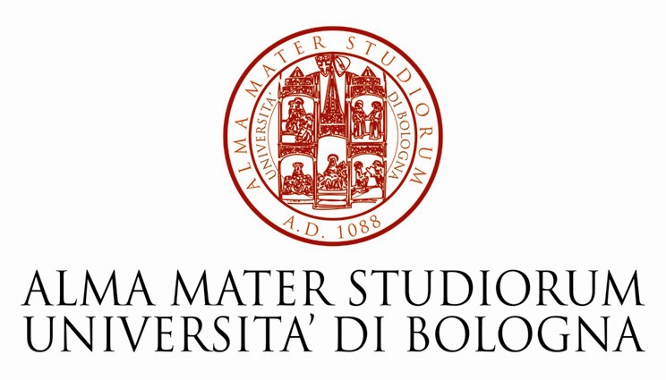


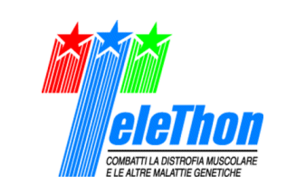
International Meeting

How to Promote Common Standards for the Evaluation of
Research Grants Applications in Europe

October 7, 2009

EuroMediterranean University Centre of Ronzano
Via di Gaibola, 16, Bologna (Italy)

The University of Bologna, the European Genetics Foundation (www.eurogene.org), Telethon Italy (www.telethon.it) and the PROGEN Consortium (www.consorzioprogen.it) under the aegis of the Italian MIUR (Ministry for Higher Education and Research) are calling this short meeting to promote a discussion on the themes related to the implementation of the best practices of peer review by public and private granting agencies in Europe. This meeting responds therefore to the need of establishing common standards for peer review of research grants in the European Union. The first step will be to compare the different systems of awarding research grants which are currently used in Europe and to try to identify a common denominator for quality assessment of these practices.
This meeting follows the 2nd Course on Peer Review in Theory and Practice, which will take place on October 5-6, 2009 in Bologna, Italy. For further information please CLICK HERE.
The meeting will consist of two parts. First, we will discuss new ideas and proposals presented by and peer-review officers and young investigators from different European countries. In the second part, a panel of international experts (invited speakers) will outline quality criteria which should be shared in principle by all peer-review systems.
The meeting will be very informal. There will be no registration fee and no publication of proceedings of the meeting.

INVITED SPEAKERS:
Ezio Andreta (National Agency for the Innovation, Milan, Italy), Renat Bilyalov (ERC, Brussels, Belgium), Fabrizio Cobis (MIUR, Rome, Italy) Keir Douglas Elam (University of Bologna, Italy) Marc Heppener (ESF, Strasbourg, France), Kenneth Keller (SAIS - Johns Hopkins University Bologna Center, Bologna, Italy),Ignazio Giacomo Massa (University of Bologna, Italy) Lucia Monaco (Telethon Foundation, Milan, Italy), Francesca Pasinelli (Telethon Foundation,Rome, Italy), Giovanni Romeo (University of Bologna, Italy), John Williams (Wellcome Trust, London, UK)

09:00 Round Table Discussion: Feed-back from the Telethon staff and students who attended the
Course of the previous two days
Moderator: Lucia Monaco

10:30 Coffee Break

11:00 Round Table Discussion: How to prepare a Strategy for the Promotion of Common
Standards for the Evaluation of Research Grants Applications in
Europe
Participants: All the invited speakers
Moderator: Giovanni Romeo
12:30 Conclusions : t.b.d.

