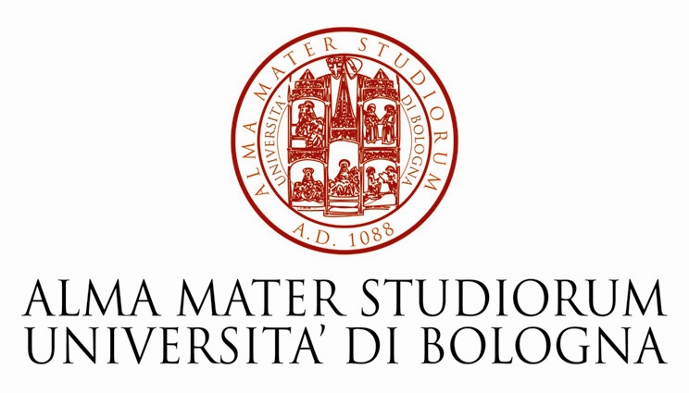
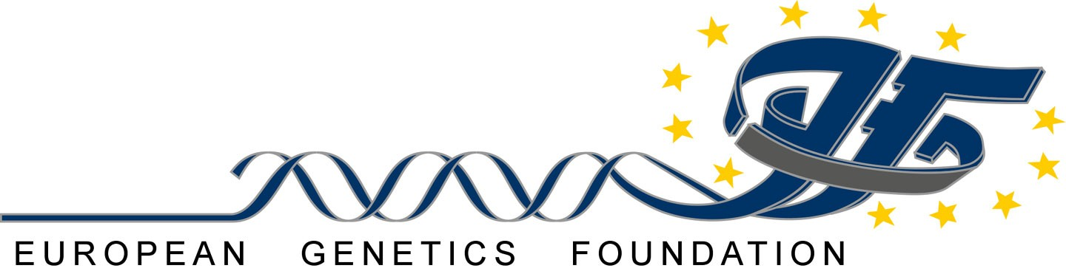

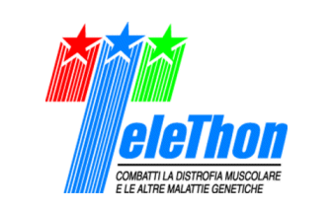
PEER REVIEW IN THEORY AND IN PRACTICE
Second Course for Scientific Officers of European Research Funding Organizations
October 5-7, 2009
EuroMediterranean University Centre of Ronzano,
Via di Gaibola, 16 , Bologna (Italy)

OUTLINE OF THE COURSE

The European Genetics Foundation (www.eurogene.org) and Telethon Italy (www.telethon.it),with the support of the PROGEN Consortium (www.consorzioprogen.it) and the University of Bologna and under the aegis of the Italian Consiglio Universitario Nazionale (CUN), are promoting for the second year a course aimed at scientific officers responsible for the organization of the peer review of research projects in all areas of science.
The aim of the course is to provide a platform of information/discussion on the themes related to the implementation of the best practices of peer review by public and private granting agencies.
The programme will offer an overview of peer review-based models adopted by leading European and American granting agencies to implement strategies for funding scientific research.
Lectures and round-tables involving policy-makers will delineate key issues and challenges for the diffusion of an effective peer-review-based system aimed at funding the best science.
Interactive workshop sessions, chaired by Telethon Scientific Officers, will be the occasion for participants to discuss key themes and policies in peer review management and compare different perspectives on the basis of their specific work experience.
The course will be aimed at scientific officers at the European level, and will accept a maximum of 50 students. The course will take place in Ronzano, Bologna (arrival Monday October 5, 2009 departure Wednesday October 7). The course will be managed by the European School of Genetic Medicine.
Applications have to be submitted on line : CLICK HERE to access the registration page
INVITED SPEAKERS:
Ezio Andreta (National Agency for the Innovation, Milan, Italy), Omer Cebeci (TUBITAK, Ankara, Turkey) Renat Bilyalov (ERC, Brussels, Belgium), Fabrizio Cobis (MIUR, Rome, Italy) Keir Douglas Elam (University of Bologna, Italy), Silvio Garattini (Mario Negri Institute, Milan, Italy), Giuliana Gemelli (University of Bologna, Italy), M. Heppener (ESF, Strasbourg, France) Kenneth Keller (SAIS - Johns Hopkins University Bologna Center, Bologna, Italy), Josè Manuel Labastida (Ministerio de Ciencia e Innovación, Madrid, Spain) Ignazio Giacomo Massa (University of Bologna, Italy), Luciano Modica (University of Pisa, Italy), Lucia Monaco (Telethon Foundation, Milan, Italy), Francesca Pasinelli (Telethon Foundation, Rome, Italy), Giovanni Romeo (University of Bologna, Italy), Lisa Vozza (AIRC, Milan, Italy), John Williams (Wellcome Trust, London, UK)

PROGRAMME

Monday, 5th October : Comparative Analysis of Different Peer Review Systems

09:00 Registration
09:30 R. Bilyalov Funding Frontier Research : ERC peer review process
10:00 J. Williams The Wellcome Trust Peer Review Process
10:30 O. Cebeci t.b.d
11:00 Coffee Break
11:30 S. Garattini The project of AIFA on independent clinical research
12:00 L. Monaco Promoting research towards the cure of genetic diseases:
how a charity faces its challenges
12:30 L. Vozza Peer review in cancer research: the AIRC review process
13:00 Discussion
13:30 Lunch Break
14:30 Parallel Workshops 1. Managing the research portfolio: one Call does not fit all
2. Key players and roles in the peer review process
16:30 Coffee Break
17:00 Parallel Workshops Workshop Wrapping up

Evening Seminar at the Collegio di Spagna:
G. Gemelli The Rockefeller Foundation and the historical roots of peer-review
in the international context
K. Keller Peer review in American research universities

Tuesday, 6th October Definition of Standards for Quality Assessment
09:00 F. Cobis t.b.d.
09:30 M. Heppener Peer Review and the European Science Foundation
10:00 J. M. Labastida Peer review and Research Funding
10:30 Coffee Break
11:00 E. Andreta The strategy of science policy in the EU
11:30 L. Modica t.b.d.
12:00 F.Pasinelli t.b.d.
12:30 Discussion
13:00 Lunch Break
14:30 Parallel Workshops 3. IT and AI tools to support and enhance peer review
4. Reviewers and reviews: optimizing the quality of the process
16:30 Coffee Break
17:00 Parallel Workshops Workshop Wrapping up

Wednesday, 7th October: Discussion of a Common Strategy for the Promotion of Peer
Review in Europe

9:00 Round Table: Feed-back from the afternoon workshops of the previous days
Participants: Telethon staff and Course students
Moderator: L: Monaco

10:30 Coffee Break
11:00 Round Table: How to prepare the future of peer review in Europe: Participants: All the invited speakers of the previous days
Moderator: G. Romeo
Conclusions : t.b.d.
13:00 Lunch and departure

