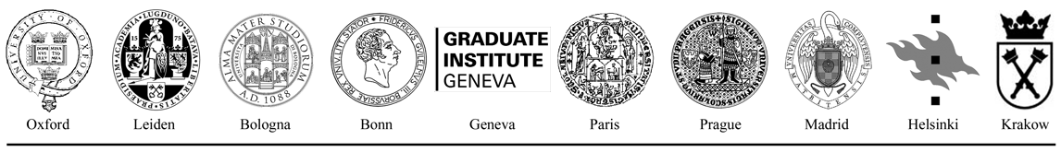


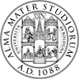
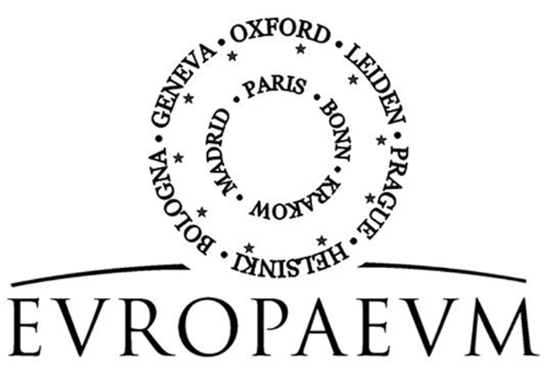

2010 SUMMER SCHOOL

The Media, Europe & Democracy
5th – 10th September 2010
at the
University of Bologna

Sunday, 5th September (Venue: Ordine dei Giornalisti, Strada Maggiore 6)
AM Arrival of participants
  - –16.00 Registration at Collegio Erasmus, via de Chiari 8
16.30 Welcome:
- Dr Carla Salvaterra, University of Bologna
- Professor Riccardo Rovelli, University of Bologna
- Dr Giovanna Filippini, University of Bologna
Introduction:
- Dr Sonia Lucarelli, University of Bologna
- Dr Paul Flather, The Europaeum
17.45 Session I:
Chair: Paul Flather, The Europaeum
Speaker: John Lloyd, Financial Times & Reuters Institute, Oxford:
Power and the Press
Discussants: Two student participants (tba) followed by general discussion.
19.00 Drinks
20.00 Dinner for Summer School participants at Ristorante Da Biagio, via de’ Coltelli 6/a
21.00 Group Introduction

Monday, 6th September (Venue: Santa Cristina, Piazzetta Giorgio Morandi 2)
9.00 Graduate Presentations I
- Felix Ohnmacht European Citizenship
- Judith Kärn Media and Democratisation
- Pegah Zohouri Muslims and the Media: Mutual Misunderstandings

10.30 Coffee break

11.00 Session II: Lecture
Chair: Sonia Lucarelli, University of Bologna
Speaker: Pierangelo Isernia, University of Siena:
European Identity and Public Space
Discussants: Two student participants (tba)
Followed by general discussion

12.30 Lunch

14.00 Session III, Round Table:
Chair: Paul Flather, the Europaeum
Is there informed public debate in Europe?

Speakers:

- Erik Jones, John Hopkins University
- Piero Ignazi, University of Bologna
- John Lloyd, Financial Times & Reuters Institute
- Alessandro Merli, Il Sole 24 Ore

General Discussion

16.00 Coffee

16.15 Graduate Working Groups I
Group A – How can we foster democracy across Europe?
Group B – How can we create a genuine European public debate?
Group C – How can Europe generate public dialogue with the USA, China and Russia?
Group D – Should the EU sponsor its own Europe-wide media?

17.00 Visit of the University

19.30 Free (dinner in town)

Tuesday, 7th September (Venue: Santa Cristina, Piazzetta Giorgio Morandi 2)
9.00 Graduate Presentations:
- Gabriela Jacomella paper tbc
- Jana Bauerova Debating European Issues: Europe-wide media (non-) existing
- Merve Kutuk How can oppressed groups express their views in the Media?

10.30 Coffee break

11.00 Session IV:
Chair: Paul Flather, the Europaeum
Speaker: Peter Mair, European University Institute, Florence:
Parties, Democracy, and the challenge to popular sovereignty
Discussants: two student participants (tba) followed by general discussion

12.30 Lunch
14.00 Session V:
Chair: Sonia Lucarelli, University of Bologna
Speaker: Furio Cerutti, University of Florence:
Political Identity in the EU
Discussants: two student participants (tba) followed by general discussion

15.30 Coffee break

15.45 Graduate Presentations
- Enzhe Gareeva How is Russia Portrayed in the European Media?
- Olga Zaporozhets How is Europe presented in the media of the old ECE region?
- Noemi Helfenstein Biases in reporting of the Russia-Georgia Crisis

17.15 Graduate Working Groups II

18.30 Reception at Il Mulino (tbc) followed by free dinner

Wednesday, 8th September (Venue: Santa Cristina, Piazzetta Giorgio Morandi 2)
9.00 Session VI:
Chair: Paul Flather, the Europaeum
Speaker: Donatella Campus, University of Bologna:
Political communication of European Leaders
Discussants: two student participants (tba) followed by general discussion

10.30 Coffee break

11.00 Research Exercise: Evaluation of the position on the EU of the European press
Introduction: Augusto Valeriani, University of Bologna: Frame analysis
Co-ordinator: Augusto Valeriani

13.00 Lunch

14.30 Session VII:
Chair: Ruth Hanau Santini
Speaker: Lorenzo Fioramonti, University of Bologna:
How is Europe portrayed in the press worldwide?
Discussants: two student participants (tba) followed by general discussion

16.00 Round Table Discussion: Communicating Europe to the Europeans and to the World
Chair: Riccardo Rovelli, University of Bologna
Speakers:
- Paddy Coulter, partner of Oxford Global Media & former director of Reuters Journalism Fellowship Programme at Oxford
- Lorenzo Consoli, President International Press Association
- Paolo Mancini, University of Perugia

18.00 Free time, prepare for reception

19.30 Reception at Federico and Giovanna Enriques’, Via San Vitale 23, Bologna
Chair: Ricardo Rovelli (tbc)
Keynote Speaker: Patrick Coulter
Has the digital revolution in Europe changed our democracy?

Thursday, 9th September (Venue: Santa Cristina, Piazzetta Giorgio Morandi 2)
9.00 Role-Playing Exercise: Deliberative democracy in Europe
Lorenzo Fioramonti, University of Bologna
Presentation and instructions

10.00 Students’ Exercise on deliberative democracy in Europe

10.45 Coffee break

11.00 Report and evaluation of Role-Playing Exercise

12.30 Lunch

14.00 Session IX:
Chair: Augusto Valeriani
Speaker: Paolo Mancini, University of Perugia: Comparing Media Systems
Discussants: Two student participants (tba) followed by general discussion

15.30 Graduate Debate

16.30 Graduate Presentations
- Libor Prochazka How is Europe presented in the Czech media?
- Veronika Frantova The Celebritization of Politicians
- Aleksandra Wagner How did the Media help in the transition from Communism to Democracy: the example of Poland
18.00 -19.00 Free Tour of Bologna
20.00 Closing Dinner at Casa Monica
Keynote Speaker: Gerardo Bombonato, Ordine dei Giornalisti
Italy and freedom of the press: risks and challenges

Friday, 10th September (Venue: Santa Cristina, Piazzetta Giorgio Morandi 2)

9.00 Session X:
Chair: Donatella Campus
Speaker: Cristian Vaccari, University of Bologna:
A Europe Wide Web? Online campaigning in Europe
Discussants: two student participants (tba) to be followed by general discussion

10.30 Coffee break

11.00 Session XI:
Chair: Riccardo Rovelli, University of Bologna
Speaker: Elena Argentesi, University of Bologna: The Media Industry in Europe
Discussants: two student participants (tbc) to be followed by general discussion

12.30 Conclusions: What have we learned?
Co-ordinated by Paul Flather and Sonia Lucarelli
Reports from Working Groups
In cases of emergency please contact:
Ruth Hanau Santini (+39-3311219864)
Sonia Lucarelli (+39-3395273350)
Paul Flather (+44-7772111358)

13.30 Lunch

PM Departure of participants

