29/10/2010, 12.00-13.00, Ravenna,
Via degli Ariani, 1

Chair: Caterina Ricciardi (Roma 3 University)

Lora Carney (Toronto University) and Marlene Goldman (Toronto University): “Aging and Memory Loss: Challenges to Self Construction in Contemporary Canadian Aesthetic Culture”

Comitato scientifico:

Silvia Albertazzi
Beatrice Battaglia
Carla Comellini
Lilla Maria Crisafulli
Keir Douglas Elam
Laura Ferri
Rita Monticelli

Comitato organizzativo:
Laura Cenacchi
Stella Giovannini
Mariella Lorusso
Francesca Martini
Laura Rizzà

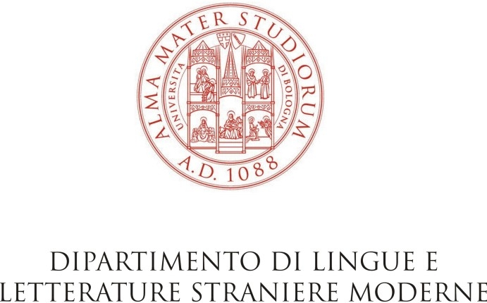

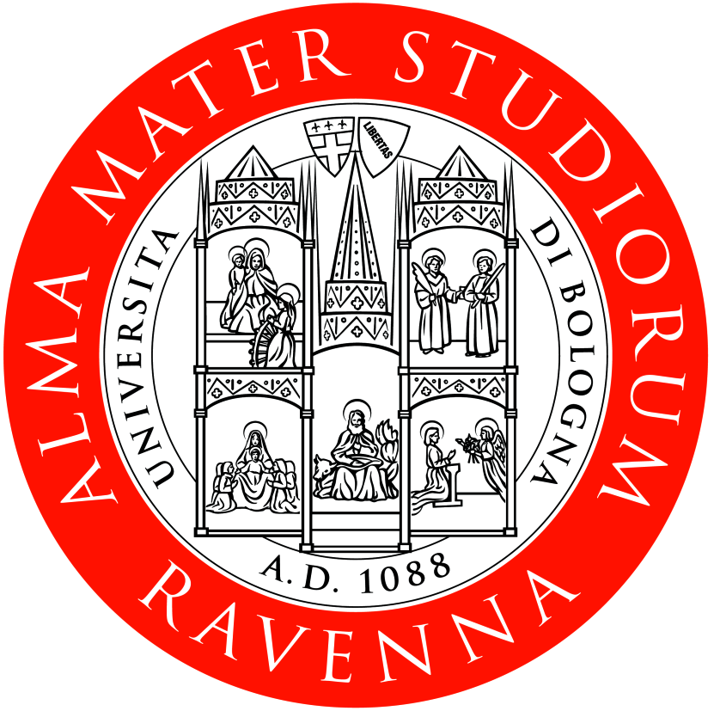
Facoltà di Conservazione dei Beni Culturali

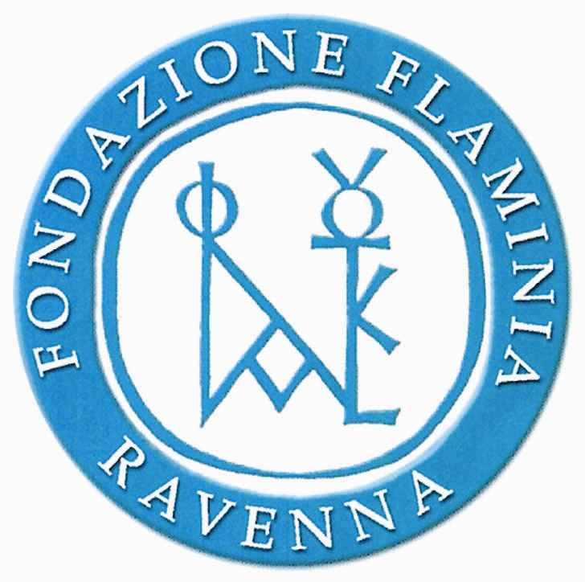

FONDAZIONE FLAMINIA
RAVENNA

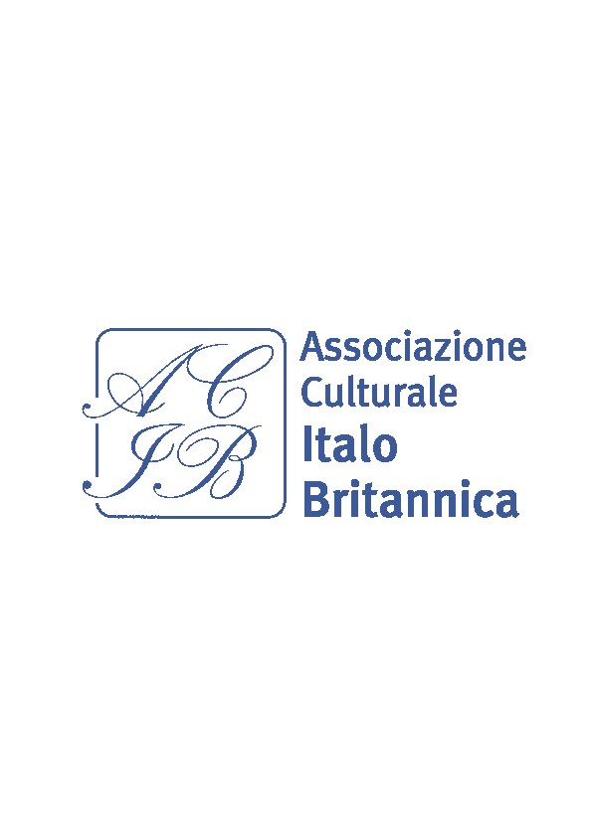

Memory and Forgetting
(Bologna/Ravenna, Bologna University, 27-29/10/2010)

Organizzato da Carla Comellini, Responsabile Scientifico del Centro Canadese “Alfredo Rizzardi”, Università di Bologna/ Convenor:
Carla Comellini, Director of the Canadian
Centre “Alfredo Rizzardi”, Bologna University

In collaborazione con/

In collaboration with

Dipartimento di Lingue e Letterature Straniere Moderne, Università di Bologna

Facoltà di Conservazione dei Beni Culturali, Università di Bologna a Ravenna

Fondazione Flaminia, Ravenna

Centro Siena-Toronto, Università di Siena

Associazione Culturale Italo Britannica,
Bologna

27/10/2010, 14.30-17.00 - Bologna, Sala Convegni, D.L.L.S.M., Via Cartoleria, 5

Chair: Lilla Maria Crisafulli (Director of the Interuniversity Centre for the Study of Romanticism, Bologna University)

Keir Douglas Elam (Head of the Department of L.L.S.M., Bologna University): “Welcome Address”

Ralph Jansen ( Minister-Counsellor, Embassy of Canada, Rome): “Welcome Remarks”

Carla Comellini (Director of the Canadian Centre “Alfredo Rizzardi”, Bologna University): “Welcome
Address”

Caterina Ricciardi (Roma 3 University): “In Memory of Alfredo Rizzardi and of the Birth of
Italian Canadian Studies”

Annapia De Luca (Director of the Centre for Canadian Culture, Udine University): “The Centre for Canadian Culture in Udine: Remembering our immigrant
Writers”

Chair: Rita Monticelli (Bologna University)

Lora Carney (Toronto University): “Diaspora, Nationalism, and Being the Other: the Work
of Joyce Wieland and Roy Kiyooka”

Marlene Goldman (Toronto University):“Jane Urquhart's Away: Irish Nationalism Comes to
Canada”

27/10/2010, 17.15-19.00, Bologna,
Associazione Culturale Italo Britannica
Via Farini, 35

Chair: Silvia Albertazzi (Director of the PhD in
Modern, Comparative and Postcolonial Literature,
Bologna University):

Martin Loeschnigg (Director of the Canadian Centre,
Graz University): “’Lest we forget’: Remembering the First World War in Contemporary Canadian Fiction”

Biancamaria Rizzardi (Director of the MA in
Translation of Postcolonial Texts, Pisa University):
“Personal Remembrances through the
Words of a Myth: Sheila Watson's
Antigone”

28/10/2010, 14.30-16.00, Ravenna,
Dismec,Via degli Ariani, 1

Chair: Carla Comellini (Director of the
Canadian Centre “Alfredo Rizzardi”, Bologna
University)

Pierfrancesco Callieri (Dean of the Faculty of Preservation of Cultural Heritage):
“Welcome Address”

Stella Giovannini (Bologna University):
“The Doleful Dark Pool of Memory: Jane
Urquhart’s Forbidden Dances”

Laura Cenacchi (Bologna University): “The Theme of Memory and Forgetting in Robertson Davies’ Trilogies”

28/10/2010, 16.15-19.00, Ravenna,
Dismec,Via degli Ariani,1

Chair: Beatrice Battaglia (Bologna University)

Mariella Lorusso (Bologna University): “The Experience of Residential Schools in Canada:
Trauma and Memory”

Laura Ferri (Director of Siena-Toronto Centre, Siena University): “Memory on The Guthrie Road, a
memoir by Rosemary Sullivan”

Carla Comellini (Bologna University):“Examples
of Memory and Forgetting in Canadian
Literature in English”

Laura Rizzà (Bologna University): “Memory
and Forgetting in Dionne Brand”

29/10/2010, 9.30-11.30, Ravenna,
Dismec,Via degli Ariani, 1
Chair: Laura Ferri (Director of Siena-Toronto
Centre, Siena University)

Caterina Ricciardi (Roma 3 University): Jane Urquhart: A Reading of the Prologue to A Map
of Glass”
-
Jon Redfern (Canadian Writer): “Memory and Forgetting: The Shape of the Past and the Contours of Memory in three Alice Munro Stories: Carried Away (Open Secrets), My Mother's Dream (The Love of a Good
Woman) and The Progress of Love (The
Progress of Love”

