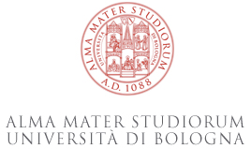 | 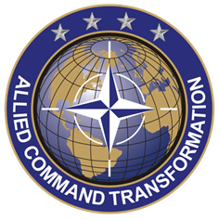 | 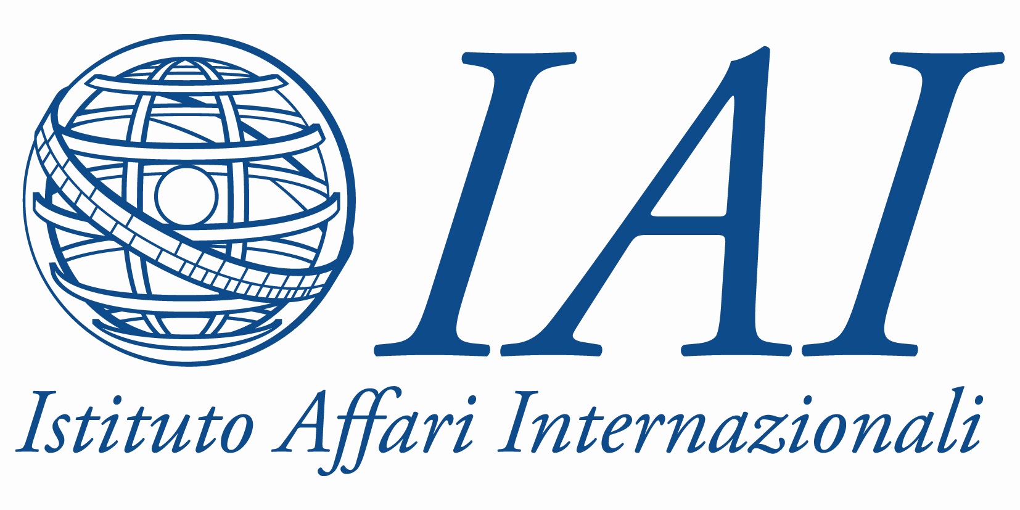 | 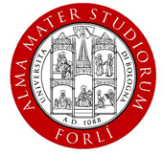

DYNAMIC CHANGE

Rethinking NATO’s Capabilities, Operations and Partnerships

International conference

in the framework of NATO Allied Command Transformation’s Academic Outreach Effort

October 26-27, 2012

Villa Guastavillani, University of Bologna

Organized by

Allied Command Transformation, Norfolk

Istituto Affari Internazionali, Rome

University of Bologna

Sponsored by

Allied Command Transformation, Norfolk

Hosted by

University of Bologna

DRAFT AGENDA

October 1, 2012

Friday, October 26

14:30-15:00 Welcome address and conference introduction

Carla Salvaterra, Vice Rector for International Relations, University of Bologna

Fabio Giusberti, Director, Department of Political and Social Sciences, University of Bologna

Ettore Greco, Director, Istituto Affari Internazionali, Rome

15:00-16:15 Keynote speech

Chair Sonia Lucarelli, Associate Professor of International Relations, University of Bologna

Peter C. Bayer, Jr, Deputy Chief of Staff, Strategic Plans and Policy, Headquarters - Supreme Allied Commander Transformation, Norfolk (VA)

Q&A

16:15-16:30 Coffee break

16:30-18:30 Plenary Session 1

FROM ATLANTIC COMMUNITY TO GLOBAL ACTOR: TAKING STOCK OF NATO EVOLUTION

Chair: Ettore Greco, Director, Istituto Affari Internazionali, Rome

Panelists: Tomas Valasek, Director, Foreign Policy and Defence, Centre for European Reform, London
Arto Räty, Permanent Secretary, Finnish Ministry of Defence, Helsinki
Peter Gray, Director, Centre for War Studies University of Birmingham, Birmingham
Sten Rynning, Head, Center for War Studies University of Southern Denmark, Copenhagen
Hanna Ojanen, Visiting Researcher, Finnish Institute of International Affairs, Helsinki

20:00 Dinner (on invitation)

KEYNOTE SPEECH: ITALY'S CONTRIBUTION TO NATO'S MILITARY OPERATIONS

Speaker : Piero Ignazi, Professor of Political Sciences, University of Bologna

Saturday, October 27

9.30-11.00 Working Groups, first session

WG1: SMART DEFENCE & THE CAPABILITY CHALLENGE

Chair: Christian Mölling, Associate, Research Division International Security, Stiftung Wissenschaft und Politik, Berlin

Paper-givers: Bastian Giegerich, Senior Researcher, Bundeswehr Institute of Social Studies, Strausberg
Daniel Keohane, Head, Strategic Affairs, FRIDE, Madrid

Discussants: Marcin Terlikowski, Analyst at the Polish Institute of International Affairs, Warsaw
Spyros Economides, Professor, London School of Economics and Political Science, London

Rapporteur: Clara O’Donnell, Fulbright Schuman Visiting Fellow, Brookings Institution, Washington DC

Open discussion

WG 2: AFGHANISTAN AND NATO AFTER 2014

Chair: Filippo Andreatta, Professor of International Relations, University of Bologna

Paper-giver: Trine Flockart, Senior Researcher, Danish Institute for International Studies, Copenhagen
Riccardo Alcaro, Senior Fellow, and Alessandro Marrone, Researcher, Istituto Affari Internazionali, Rome

Discussants: Martine van Bijlert, Co-director, Afghanistan Analyst Network, Kabul
Mungo Melvin, Senior Associate Fellow, Royal United Services Institute, London

Rapporteur: Federico Catapano, Concept Development Branch, Headquarters - Supreme Allied Commander Transformation, Norfolk (VA)

Open discussion

WG3: NATO PARTNERSHIP IN NORTH AFRICA AND MIDDLE EAST

Chair: Alessandro Minuto Rizzo, Former NATO Deputy Secretary General

Paper-giver: Gulnur Aybet, Senior Lecturer, International Relations, University of Kent
Jeffrey Reynolds and Dick Bedford, Strategic Issues & Engagements Branch, Headquarters - Supreme Allied Commander Transformation, Norfolk (VA)

Discussants: Memduh Karakullukcu, Global Relations Forum, Ankara
Abdennour Benantar, Associate Professor at the Department of Political Science, University of Batna, Algeria

Rapporteur: Emiliano Alessandri, Senior Transatlantic Fellow, German Marshall Fund, Washington DC

Open discussion

11.00-11.15 Coffee break

11.15-12.45 Working Groups, second session

12:45-14:15 Buffet Lunch

14:15-16:15 Plenary Session 2

BEYOND THE ATLANTIC: NATO’S NEW HORIZONS

Chair: Sonia Lucarelli, Associate Professor of International Relations, University of Bologna

Reports by Working Group rapporteurs*

Panelists: Anthony Cordesman, Arleigh A. Burke Chair in Strategy, Center for Strategic and International Studies (CSIS)
Camille Grand, Director, Fondation pour la recherche stratégique, Paris
Stefano Silvestri, President, Istituto Affari Internazionali
Stefani Weiss, Director, Europe´s Future and International Governance programs Beterlsmann Stifftung, Brussels
Julian Lindley-French, Eisenhower Professor of Defence Strategy, Netherlands Defence Academy

Final remarks: Peter C. Bayer, Jr, Deputy Chief of Staff, Strategic Plans and Policy, Headquarters - Supreme Allied Commander Transformation, Norfolk (VA)

*This section will include 5 minutes for each rapporteur to outline few key issues discussed by working groups.

