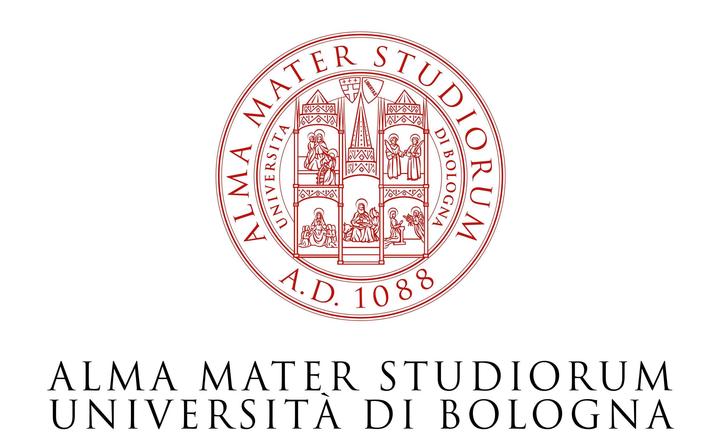
Dipartimento di Storia, Culture e Civiltà

PHaSI
Philanthropy and Social Innovation Research Centre

Nell’ambito del Dottorato in Storia
Indirizzo Global Studies in Philanthropy

Organizzano il seminario

The Politics of Philanthropy: Shifts in Philanthropic Practices in Egypt, Libya and Tunisia

Partecipano:

Sherine al-Taraboulsi

Research Manager at John D. Gerhart Center for Philanthropy and Civic Engagement
American University in Cairo

Marco Kirschbaum

NGO Management School Switzerland, Geneva
Executive Director

Introduce: Giuliana Gemelli, Omar Bortolazzi
Università degli Studi di Bologna

Mercoledì 21 novembre 2012
Ore 15
Aula Gambi
Dipartimento di Discipline Storiche
P.zza San Giovanni in Monte 2
40124 Bologna

