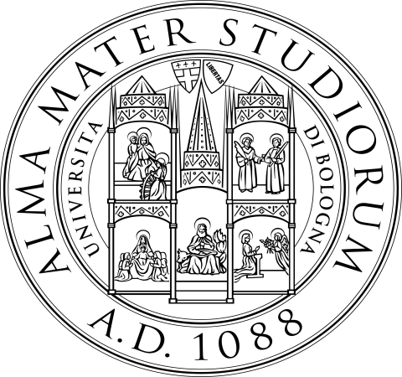

Alma Mater Studiorum - Università di Bologna

SEMINAR

Andrea AMELIO
(Chief Economist Team, Directorate-General for Competition of the European Commission)

Recent merger cases at the European Commission:
- A merger in the music industry: Universal/EMI
- Competition policy in two sided-markets and internet search (with reference to the Microsoft/Yahoo case)

Date: Friday, 29th November 2013

Time: 12 - 1.30 p.m.

Location: Scuola di Economia, Management e Statistica
Lecture Hall # 3 - (Ground floor) - Piazza Scaravilli, 2 – 40126 Bologna

